The Mathematics of
“The DaVinci Code”
by Dan Brown

Speaker:

Gerry Wildenberg

Department of Mathematical and Computing Sciences
St. John Fisher College


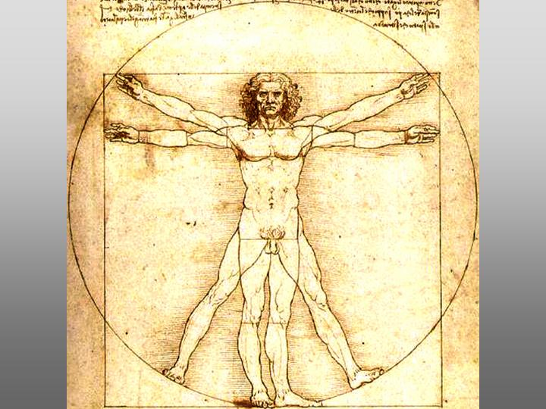
Vitruvian Man – Leonardo Da Vinci

Who was Leonardo?
- A great artist:
  - Mona Lisa
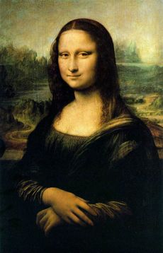 | 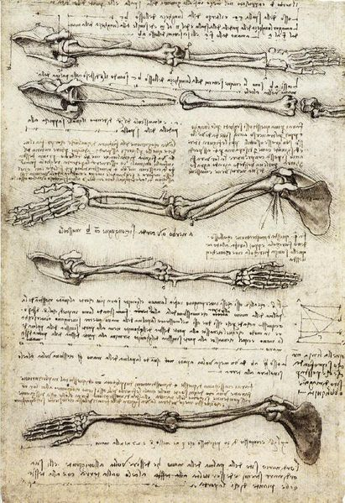
  - Last Supper
  - Vitruvian Man
- An inventor
- Anatomist

Vitruvian Man

~~~~~~~~~~~~~~~~~~~~~~~~~~~~~~~~~~~~~~~~
~~~~~~~~~~~~~~~~~~~~~~~~~~~~~~~~~~~~~~~~

Interesting partly because it is an interesting debate whether or not the Golden Ratio is intentionally illustrated or not.

The Golden Ratio -- Phi φ

Point B is to be chosen so that:
AC/AB = AB/BC

Since AC=AC+BC, this is equivalent to saying: (a+b)/a = a/b

Then a little algebra shows that a/b is the solution of 1+1/x = x or x²-x-1 = 0

This ratio is:
$$ϕ=\frac{1+\sqrt{5}}{2}≈1\text{.}\text{618}$$

1+1/x = x and x² = x+1 mean that φ has some neat properties algebraically.

From 1+1/x = x rewritten as:
1/x = x - 1
we see that we can find the reciprocal of φ just by subtracting 1.

And from x² = x+1, we see that we can square φ just by adding 1.

But why Phi? I.e. Why φ?

This is part of the Parthenon.

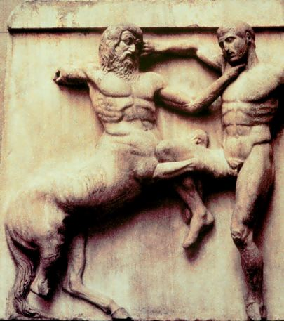

The chief sculpture is usually said to be Phidias
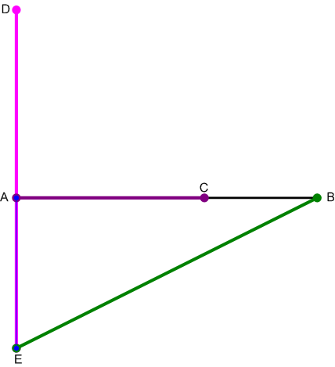

Euclid developed a simple construction.
To divide AB into the Golden Ratio, we bisect AB (not shown) and measure off that distance (downward) on the perpendicular at A. AE=1/2(AB). Then we extend AE upward to D so that ED=BE. Then if we measure on AB the length AD, (AC=AD) we have the desired ratio. (The proof involves either some unfamiliar geometry or some algebra.)
Why is the Golden Ratio involved in the pentagram?

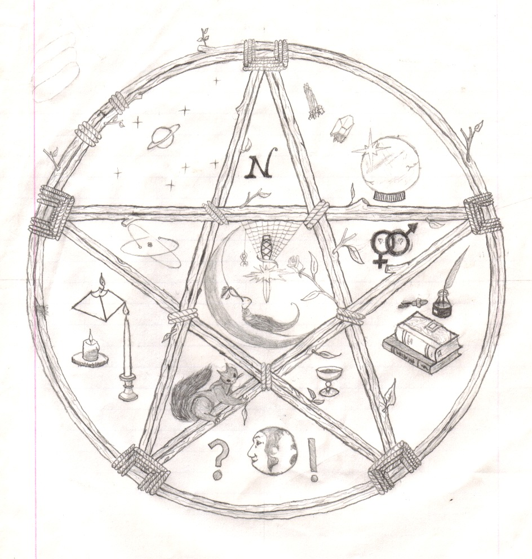

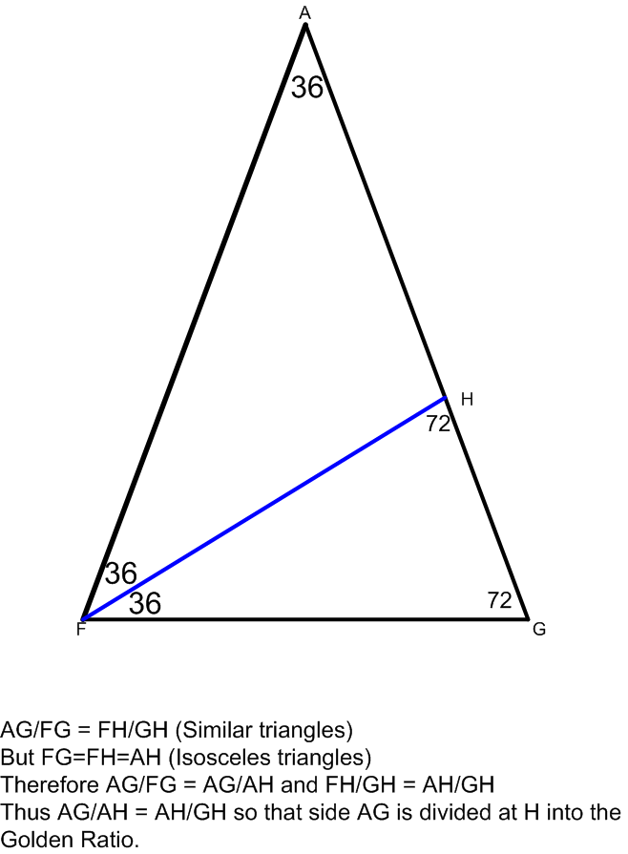

Pentagram in a pentagon

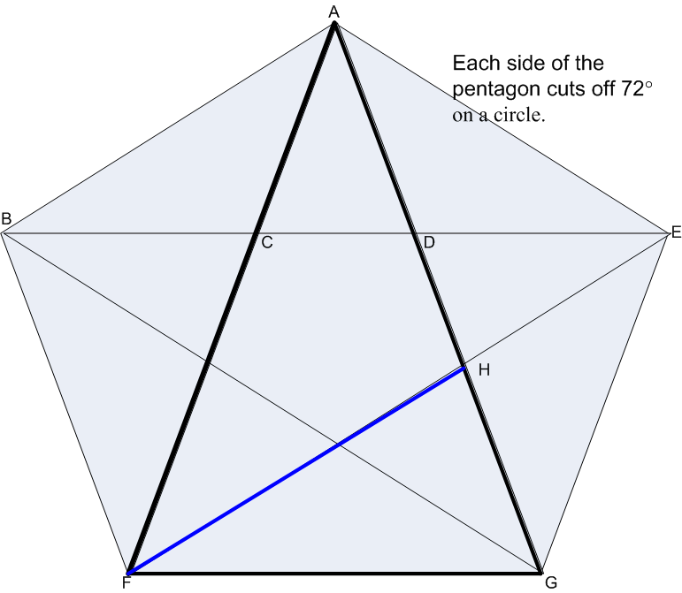

Note that there are small, medium and large 36°, 72°, 72° triangles. Thus the Golden Ratio is “everywhere” in the pentagram.
Since φ is a solution to: 1+1/x = x ,

we can describe φ as the intesection of y=x and y=1+1/x

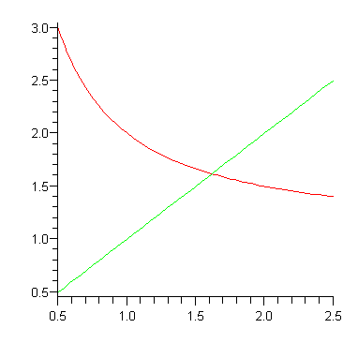
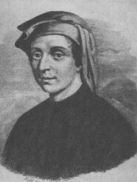Fibonacci a/k/a Leonardo of Pisa
- Name means “son of Bonaccio” and “bonnaci” means good-hearted.

- Brought Hindo/Arabic arithmetic to Europe in his book “Liber Abaci” – The Book of Calculation (1202) !!!!!!!!!

- Also a chapter on what later became known as the:

Fibonacci Sequence

Sequence is based on the following unrealistic assumptions.
- Rabbits live forever and never lose ability to breed.
- Each pair of “mature” rabbits gives birth to a mixed pair of rabbits each month.
- A pair of newborn rabbits becomes “mature” after two months.
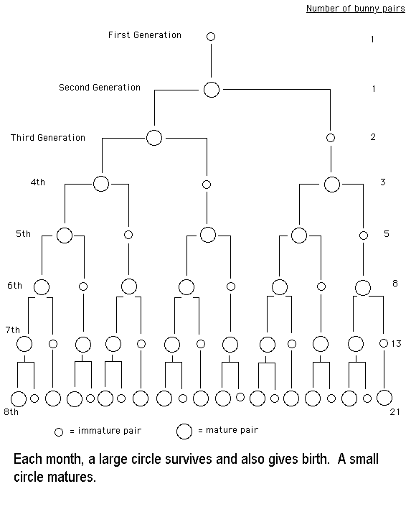
So: 1, 1, 2, 3, 5, 8, 13, 21, …

More generally, let’s ask how many we have at generation n.
- All of the rabbits from the previous generation survive.
- All of the rabbits which are at least two generations old give birth. But this number is just the ones that were alive 2 generations back.

F₁=1, F₂=1, F_{n} = F_{n-1} + F_{n-2}

Many interesting properties but let’s start by showing a connection with Phi.

F_{n} = F_{n-1} + F_{n-2}

F_{n}/ F_{n-1} = 1 + F_{n-2} /F_{n-1}

F_{n}/ F_{n-1} = 1 + 1/(F_{n-1} /F_{n-2})

Now if the ratios of the successive terms is converging to some number, say X,
F_{n}/ F_{n-1} = 1 + 1/(F_{n-1} /F_{n-2})
↓ ↓ ↓
X = 1 + 1/X

which tells us that F_{n}/ F_{n-1} → Φ . Notice that we never used the starting values of the sequence in this argument.
This illustrates that the starting values don’t affect the limit of the ratio of terms.
2 |  |  | 1
5 | 2.50000 |  | 1 | 1.00000
7 | 1.40000 |  | 2 | 2.00000
12 | 1.71429 |  | 3 | 1.50000
19 | 1.58333 |  | 5 | 1.66667
31 | 1.63158 |  | 8 | 1.60000
50 | 1.61290 |  | 13 | 1.62500
81 | 1.62000 |  | 21 | 1.61538
131 | 1.61728 |  | 34 | 1.61905
212 | 1.61832 |  | 55 | 1.61765
343 | 1.61792 |  | 89 | 1.61818
555 | 1.61808 |  | 144 | 1.61798
898 | 1.61802 |  | 233 | 1.61806
1453 | 1.61804 |  | 377 | 1.61803
2351 | 1.61803 |  | 610 | 1.61804
3804 | 1.61803 |  | 987 | 1.61803
6155 | 1.61803 |  | 1597 | 1.61803

For a proof that F_{n}/ F_{n-1} actually does converge we look at the alternate terms. Here are a few of the details:

Let a_{n} = F_{n}/ F_{n-1}
We already showed that a_{n+1} = 1 + 1/a_{n} .
Therefore:
$$a_{n+2}=1+\frac{1}{a_{n+1}}=1+\frac{1}{1+\frac{1}{a_{n}}}=1+\frac{a_{n}}{1+a_{n}}$$
Using this we can next prove that the even terms decrease and the odd terms increase. (Hint: calculate a_{n+2} - a_{n} in terms of a_{n} - a_{n-2.}) And then we can also show that each converge to the same limit.

From this the convergence of F_{n}/ F_{n-1} follows.
An amazing formula for the Fibonacci number is:

$F_{n}=\frac{1}{\sqrt{5}}\left({\left(\frac{1+\sqrt{5}}{2}\right)}^{n}−{\left(\frac{1−\sqrt{5}}{2}\right)}^{n}\right)$
One of the reasons that this formula is so amazing is that, contrary to one’s immediate instincts, this formula always yields an integer. (Try it!)

Note that the two terms that are raised to the nth power are Phi and 1-Phi, which are the two roots of x²-x-1=0

The Fibonacci Sequence has a clever geometric viewpoint. We can cover the plane with squares that do not repeat after the first two by following this idea. Copy a square of side 1 by placing a 2nd square to the right. Then put a square of side 2 on top, then a square of side 3 to the left and then a square of side 5 below. Next would come a square of side 8 to the right.
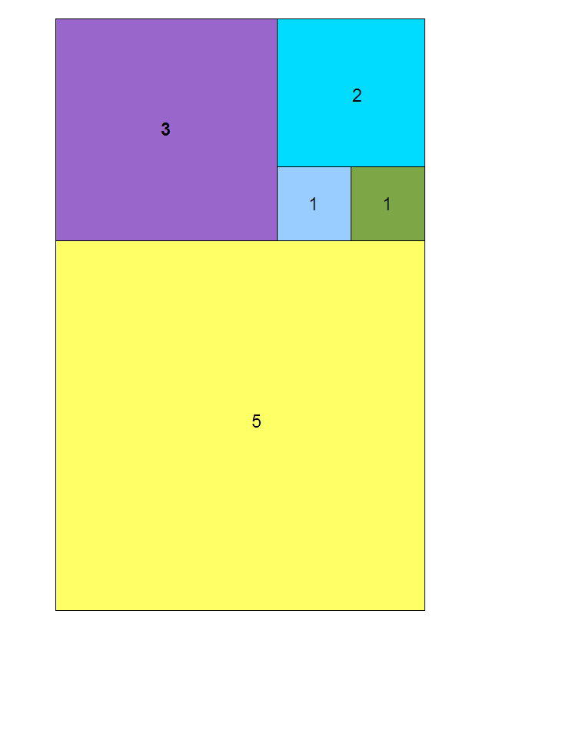
This can also be used to draw a spiral by putting quarter circles in each square.

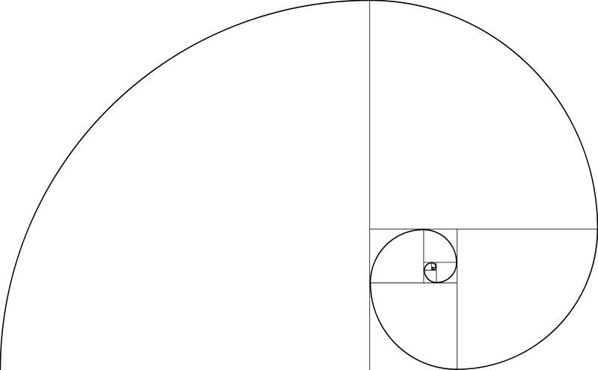

Is Phi really illustrated in paper sizes or buildings?

Name | in × in | mm × mm | Ratio | Alias | Similar ISO size
ANSI A | 8½ × 11 | 279 × 216 | 1.2941 | Letter | A4
ANSI B | 11 × 17 | 432 × 279 | 1.5455 | Ledger, Tabloid | A3
ANSI C | 17 × 22 | 539 × 432 | 1.2941 |  | A2
ANSI D | 22 × 34 | 864 × 539 | 1.5455 |  | A1
ANSI E | 34 × 44 | 1118 × 864 | 1.2941 |  | A0

Name | in × in | mm × mm | Ratio
Arch A | 12 × 9 | 305 × 229 | 4:3
Arch B | 18 × 12 | 457 × 305 | 3:2
Arch C | 24 × 18 | 610 × 457 | 4:3
Arch D | 36 × 24 | 914 × 610 | 3:2
Arch E | 48 × 36 | 1219 × 914 | 4:3
Arch E1 | 42 × 30 | 1067 × 762 | 7:5
Name | in × in | mm × mm | Ratio
Quarto | 8 × 10 | 203 × 254 | 1.25
Foolscap | 8 × 13 | 203 × 330 | 1.625
Executive, Monarch | 7¼ × 10½ | 184 × 267 | 1.4483
Government-Letter | 8 × 10½ | 203 × 267 | 1.3125
Letter | 8½ × 11 | 216 × 279 | 1.2941
Legal | 8½ × 14 | 216 × 356 | 1.6471
Ledger, Tabloid | 11 × 17 | 279 × 432 | 1.5455
Post | 15½ × 19½ | 394 × 489 | 1.2419
Crown | 15 × 20 | 381 × 508 | 1.(3)
Large Post | 16½ × 21 | 419 × 533 | 1.(27)
Demy | 17½ × 22½ | 445 × 572 | 1.2857
Medium | 18 × 23 | 457 × 584 | 1.(27)
Royal | 20 × 25 | 508 × 635 | 1.25
Elephant | 23 × 28 | 584 × 711 | 1.2174
Double Demy | 22½ × 35 | 572 × 889 | 1.(5)
Quad Demy | 35 × 45 | 889 × 1143 | 1.2857
Statement | 5½ × 8½ | 140 × 216 | 1.5455
Index card | 3 × 5 | 76 × 127 | 1.(6)
Index card | 4 × 6 | 102 × 152 | 1.5
Index card | 5 × 8 | 127 × 203 | 1.6
International business card | 2⅛ × 3.37 | 55 × 85.6 | 1.586
US business card | 2 × 3½ | 89 × 51 | 1.75

Are the fibonacci numbers present in nature?

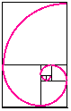 | 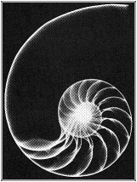

Ratio on navel to total height is .604 close to .618 but …
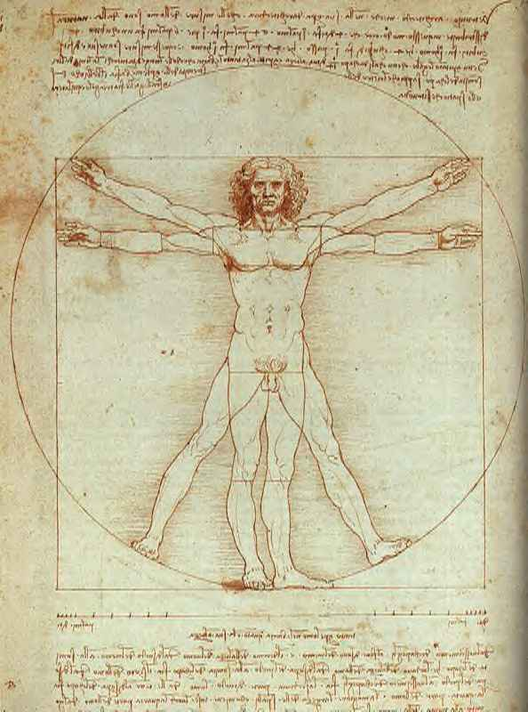
Summary
Φ and the Fibonacci Sequence certainly provide interesting Mathematics. Whether or not they do a good job in describing nature or art is debatable and I leave that to you to decide for yourself.

